

CUSTOMER SEGMENTATION

A PROJECT REPORT
Submitted by

ASWIN RAM R M 95072217013
in partial fulfillment for the award of the degree of

BACHELOR OF TECHNOLOGY
in
ARTIFICIAL INTELLIGENCE AND DATA SCIENCE

FRANCIS XAVIER ENGINEERING COLLEGE
(Autonomous)
TIRUNELVELI – 627 003

APRIL 2026

FRANCIS XAVIER ENGINEERING COLLEGE
(Autonomous)
TIRUNELVELI 627 003 BONAFIDE CERTIFICATE

Certified that this project report “Flight delay Analysis and prediction” is the bonafide work of “ASWIN RAM R M 95072217017” who carried out the project work under my supervision. Certified further that to the best of my knowledge the work reported herein does not form part of any other thesis or dissertation on the basis of which a degree or award was conferred on an earlier occasion on this or any other candidate.

Mrs.S. Bernisha, Dr. A. Jainul Fathima, M.Tech .
SUPERVISOR HEAD OF THE DEPARTMENT
Assistant Professor, Professor and Head,
Department of AI & DS, Department of AI & DS,
Francis Xavier Engineering College Francis Xavier Engineering College Tirunelveli. Tirunelveli.

Submitted for the B.Tech Degree Project Viva Voce held on ……………………

INTERNAL EXAMINER EXTERNAL EXAMINER

ACKNOWLEDGEMENT

It gives us immense pleasure and satisfaction to present this report on the project undertaken during the Final year of B.TECH. As it is the first step into our Professional Life, we would like to take this opportunity to express our sincere thanks to several people, without their help and encouragement, it would have been impossible for us to carry out the desired work.
We would like to express our sincere thanks to our Chairman Dr. S. Cletus Babu, Principal Dr. V. Velmurugan, and Head of Department Dr. A. Jainul Fathima from the bottom of our hearts, who allowed us to undertake such great challenging, and innovative work.
The gratitude is also extended to our project Guide Assistant Professor, A. Angeline Valentina Sweety, M.E.,(Ph.D). Artificial Intelligence and Data Science for sharing his pearl of wisdom with us during the development of this project.
We express our deep sense of gratitude and sincere thanks to our project coordinator Mrs. R. Janet M. Tech., Assistant Professor, for giving me encouragement and highly valuable advice for the entire course of this project work.
We place on record our sincere thanks to Professor Dr. P. Kannan for being a constant source of motivation for us. By her uncompromising demand for quality and her insistence for meeting the deadlines, we could do such excellent work.
Finally, we thank our college Francis Xavier Engineering College for providing us with a supporting environment. We thank them for providing us such a warm atmosphere to make our Project work development experience delightful and memorable.

ABSTRACT
Road accidents remain a major public safety concern in India, accounting for a significant number of fatalities, injuries, and economic losses every year. To address these challenges, this project presents an integrated, data-driven solution that combines historical accident analysis, machine learning–based risk prediction, and transformer-driven safety recommendations within a unified web application. Historical analysis is performed using accident datasets from Kaggle and the Ministry of Road Transport and Highways (MoRTH), enabling the identification of temporal patterns, geographic hotspots, severity distributions, and contributing factors such as road type, vehicle category, lighting conditions, and weather. To enhance proactive safety, a Machine Learning Risk Predictor is developed to classify accident severity as Low, Medium, or High Risk based on environmental and situational attributes. The predictive model assists users in understanding potential danger levels before engaging in specific driving scenarios. To further strengthen safety awareness, the system incorporates a transformer-based recommendation engine powered by Google Gemini API, which generates contextual, human-like safety suggestions tailored to the predicted risk level. All three components—analytics, prediction, and AI-based recommendations—are deployed inside a fully interactive web application built using Node.js and Vite, ensuring high performance, scalability, and seamless user interaction. This combined approach transforms raw accident data into actionable intelligence, offering insightful visualizations, real-time risk assessments, and personalized driving recommendations.
Keywords: Road Accident Analysis, Machine Learning, Risk Prediction, Gemini API, Transformer Model, Node.js, Vite, MoRTH, Kaggle Dataset, Safety Recommendation System.

TABLE OF CONTENTS

CHAPTER | TITLE | PAGE  NO
 | ACKNOWLEDGEMENT | iii
 | ABSTRACT | iv
 | LIST OF FIGURES | vii
 | LIST OF ABBREVIATIONS | viii
1 | INTRODUCTION | 3
 | 1.1 Background of the Aviation Industry and Flight Delays
 | 1.2 Significance of Flight Delay Prediction | 6
 | 1.3 Objectives of the Project | 7
2 | PROBLEM STATEMENT  2.1 The Economic and Social Impact of Flight Delays  2.2 Challenges in Identifying Delay Factors  2.3 Limitations of Current Predictive Measures  2.4 The Need for a Data-Driven Machine Learning Approach | 9
3 | LITERATURE REVIEW | 13
 | 3.1 Historical Approaches to Flight Delay Analysis | 13
 | 3.2 Recent Advancements in Machine Learning for Aviation | 13
 | 3.3 Comparative Analysis of Predictive Models (e.g., Random Forest, XGBoost) | 13
 | 3.4 Gaps in Existing Research and Literature
4 | EXISTING SYSTEM  4.1 Overview of Traditional Flight Scheduling Systems  4.2 Methods Currently Used by Airlines for Delay Estimation  4.3 Drawbacks and Inefficiencies of the Existing System | 18
5 | PROPOSED SOLUTION | 22
 | 5.1 Architecture of the Proposed Predictive Model | 23
 | 5.2 Key Features and Advantages Over Existing Systems | 24

 | 5.3 Expected Outcomes and Performance Improvements | 25
 | 5.4 Feasibility and Practical Application in the Real World
6 | METHODOLOGY | 29
 | 6.1 Data Collection and Description | 29
 | 6.2 Data Preprocessing and Exploratory Data Analysis | 30
 | 6.3 Feature Engineering and Selection | 31
 | 6.4 Model Selection, Training, and Validation | 31
 | 6.5 Evaluation | 32
7 | RESULT AND DISCUSSION  7.1 Model Performance Evaluation  7.2 Impact of Feature Selection and Data Preprocessing  7.3 Comparative Analysis and Practical Implications | 34
8 | CONCLUSION | 38
 | 8.1 Conclusion | 38
 | 8.2 Future Scope | 40
 | APPENDIX 1 | 43
 | APPENDIX 2 | 44
 | REFERENCES | 46

FIGURE NO | NAME OF THE FIGURE | PAGE NO
6.1 | Workflow Diagram | 30
6.2 | Data Acquisition | 31
LIST OF FIGURES

CHAPTER 1 INTRODUCTION
The aviation industry is a critical backbone of global transportation, facilitating the movement of millions of passengers and tons of cargo daily. However, flight delays remain one of the most pervasive and costly challenges faced by airlines, airports, and passengers worldwide. These delays not only result in massive financial losses for airline operators due to increased fuel consumption, crew overtime, and rebooking expenses, but they also cause significant frustration and disrupted schedules for travelers. As air traffic volume continues to grow, the complexity of managing flight schedules and mitigating delays has grown exponentially.
The primary objective of this project, "Flight Delay Analysis and Prediction," is to leverage historical flight data to understand the underlying patterns of flight delays and build a robust machine learning model capable of predicting future delays with high accuracy. While some delays caused by extreme weather or sudden mechanical failures are unavoidable, a vast majority of delays follow identifiable trends influenced by factors such as departure time, airline carrier, airport congestion, and seasonal variations. By performing comprehensive Exploratory Data Analysis (EDA) and applying advanced predictive algorithms, this study aims to transition from reactive delay management to a proactive forecasting approach.
The scope of this project encompasses the end-to-end machine learning pipeline, starting from data extraction and cleaning to feature engineering, model training, and performance evaluation. By identifying the key predictors of flight delays, this proposed system intends to provide actionable insights for aviation stakeholders, ultimately improving operational efficiency and enhancing the overall passenger experience. The subsequent sections of this report will detail the methodologies employed, the models evaluated, and the final results achieved in this predictive analysis.

Background of the Aviation Industry and Flight Delays
The aviation industry is one of the most important sectors supporting global connectivity, economic development, tourism, and international trade. Over the past few decades, the number of air travelers has increased significantly, leading to higher flight frequency and more complex airline operations. With this growth, managing flight schedules efficiently has become a major challenge. Flight delays are a frequent issue caused by various factors such as adverse weather conditions, air traffic congestion, technical malfunctions, crew availability, and airport operational constraints. These delays can propagate across multiple flights, creating a ripple effect throughout the network. As airports become busier and airspace becomes more crowded, the impact of delays continues to grow. Addressing this issue is critical for maintaining operational stability and improving the overall efficiency of the aviation system worldwide.

Significance of Flight Delay Prediction
Flight delay prediction plays a crucial role in modern aviation management by enabling airlines and airports to make informed, data-driven decisions. Accurate delay predictions allow airlines to proactively adjust schedules, optimize crew and aircraft allocation, and reduce the cascading effects of delays. For passengers, it enhances travel experience by providing timely updates and reducing uncertainty. Traditional statistical approaches often fail to capture the complex and dynamic nature of flight delays, especially when multiple factors interact simultaneously. With advancements in data analytics and machine learning, it is now possible to build predictive models that deliver higher accuracy and reliability. This capability is highly significant in reducing operational costs, improving punctuality, enhancing customer satisfaction, and ensuring better utilization of airport infrastructure in an increasingly competitive aviation industry.

Objectives of the Project
The main objective of this project is to design and develop an intelligent flight delay prediction system using advanced machine learning techniques. The project aims to analyze large volumes of historical flight data along with external factors such as weather conditions, airport traffic, and scheduling patterns to identify key contributors to delays. It also focuses on implementing and comparing multiple predictive models, including Random Forest and XGBoost, to achieve optimal performance. Another objective is to improve prediction accuracy through proper data preprocessing, feature selection, and model tuning. Additionally, the system is intended to provide actionable insights that can help airlines optimize operations, minimize delays, and enhance passenger satisfaction. Ultimately, the project seeks to contribute to more efficient and reliable air transportation systems.

.

CHAPTER 2 PROBLEM STATEMENT

Flight delays represent a multi-billion-dollar dilemma for the global aviation industry, introducing profound operational and economic friction. When a flight fails to depart or arrive on schedule, airlines are immediately burdened with a cascade of direct and indirect costs. These include increased fuel burn from holding patterns, extended compensation for flight crews, logistical nightmares involving connecting flights, and the heavy financial toll of passenger compensations and rebookings. Beyond the balance sheet, chronic delays severely erode brand trust and customer loyalty, as passengers increasingly demand reliability and transparency.
Flight delays are a persistent challenge in the aviation industry, affecting operational efficiency, airline profitability, and passenger satisfaction. With the rapid growth in air traffic, airlines face increasing difficulty in maintaining on-time performance due to multiple dynamic factors such as weather conditions, air traffic congestion, technical issues, and airport limitations. These delays often lead to cascading effects, where a delay in one flight impacts several subsequent flights, which are often inadequate to handle the complexity and large volume of aviation data.
There is a critical need for an intelligent and data-driven system that can accurately predict flight delays in advance. Such a system should be capable of analyzing historical and real-time data to identify patterns and key influencing factors. Machine learning approaches, including models like Random Forest and XGBoost, offer promising solutions due to their ability to handle complex relationships and large datasets. The challenge lies in developing a robust model that delivers high accuracy and reliability, enabling airlines to take proactive measures and improve overall operational efficiency.

The core problem lies in the sheer unpredictability and interconnectedness of the factors causing these disruptions. Variables such as localized weather anomalies, air traffic control bottlenecks, sudden mechanical failures, and delayed turnaround times create a highly volatile operational environment. Furthermore, existing mitigation strategies are fundamentally reactive, often addressing the symptoms of a delay rather than anticipating its occurrence.
Consequently, aviation stakeholders lack the foresight required to optimize resources dynamically. Addressing this critical blind spot necessitates a sophisticated, predictive approach capable of deciphering complex data patterns to forecast disruptions before they manifest, thereby mitigating the severe financial and reputational damage inflicted by chronic flight delays.
2.1 The Economic and Social Impact of Flight Delays :
Flight delays represent a massive operational and financial bottleneck within the global aviation ecosystem. For airlines, the economic toll is staggering, manifesting in the form of increased fuel consumption, extended crew shifts, costly passenger compensation, and disrupted maintenance schedules. Beyond the direct financial impact on carriers, flight delays create significant social and economic friction for passengers. Travelers experience missed connecting flights, lost business productivity, and immense frustration, which ultimately damages airline brand reputation and long-term customer loyalty. Furthermore, the cascading nature of these delays means that a single disrupted flight can trigger a domino effect, impacting the efficiency of multiple airports and thousands of passengers across the broader air traffic network.
2.2 Challenges in Identifying Delay Factors
Accurately attributing and anticipating the causes of these delays is a highly complex challenge. The aviation environment is incredibly dynamic, with flight punctuality dependent on a wide array of interconnected and constantly fluctuating variables. Factors such as sudden adverse weather conditions, air traffic control congestion, unexpected mechanical failures, and logistical delays in ground handling all contribute to scheduling uncertainty. Because these operational variables often interact in unpredictable ways, isolating a single root cause for a delayed flight is frequently impossible, making traditional analytical methods inadequate for modern aviation demands.
2.3 Limitations of Current Predictive Measures
Historically, airlines and aviation authorities have relied on basic statistical models, simple buffer times, and historical averages to estimate flight durations and manage schedules. However, these conventional systems suffer from significant limitations. They are largely reactive and fail to account for the complex, non-linear relationships that exist within modern flight data. Simple rule-based systems cannot rapidly adapt to real-time operational changes or synthesize the sheer volume of data generated by daily flight operations. As a result, the predictions generated by existing legacy systems are often inaccurate, leaving airlines ill-equipped to make proactive, cost-saving decisions.
2.4 The Need for a Data-Driven Machine Learning Approach
Consequently, there is an urgent and critical need to transition from traditional, static estimation methods to advanced, data-driven predictive systems. The modern aviation industry requires a robust analytical approach capable of processing vast datasets to uncover hidden patterns and operational correlations. By implementing machine learning techniques, we can build sophisticated models that not only analyze historical flight data but also learn from it to forecast future delays with high precision. This project addresses this critical gap by proposing a machine learning solution that empowers airlines to anticipate delays, optimize their scheduling operations, and ultimately deliver a more reliable and seamless travel experience for passengers.
CHAPTER 3 LITERATURE REVIEW

The academic and industrial pursuit of minimizing flight delays has generated a rich body of literature, evolving significantly over the past few decades. Early research in aviation analytics predominantly utilized traditional statistical models, such as linear regression and queuing theory, to estimate the probability of delays. While these foundational studies provided valuable insights into the fundamental mechanics of air traffic flow, they frequently fell short in capturing the highly non-linear and interdependent relationships inherent in modern aviation networks. As computing power and data storage capacities expanded, recent literature has witnessed a decisive pivot towards machine learning and artificial intelligence.
Contemporary researchers have extensively documented the efficacy of complex algorithms—ranging from Support Vector Machines to advanced ensemble methods like Random Forest and Gradient Boosting—in parsing vast, multi-dimensional flight datasets. These studies consistently highlight the superior accuracy of machine learning over traditional statistics in predicting operational bottlenecks. However, a critical review of the current landscape reveals a noticeable gap: much of the existing research remains heavily theoretical, focusing on algorithmic optimization while neglecting the practical, user-facing implementation of these models. This project bridges that gap by applying these validated machine learning principles into a highly functional, analytical framework.

Historical Approaches to Flight Delay Analysis
Early research into flight delay analysis primarily relied on traditional statistical techniques and queuing theory. Historically, aviation analysts utilized linear regression, time-series analysis, and basic probabilistic models to estimate delays based on historical averages and scheduled buffer times. While these foundational studies provided initial insights into the temporal and spatial distribution of air traffic congestion, they were inherently limited. Traditional models often assumed linear relationships between variables, failing to capture the complex, interdependent, and highly dynamic nature of modern aviation networks. Consequently, these early systems struggled to provide accurate, real-time predictions when faced with unexpected operational disruptions.

Recent Advancements in Machine Learning for Aviation
Traditionally, The exponential growth of big data in the aviation sector has prompted a paradigm shift in recent literature, moving away from static statistics toward dynamic machine learning methodologies. Modern research extensively documents the integration of massive datasets—encompassing historical flight logs, real-time meteorological data, air traffic control communications, and aircraft telemetry—to train sophisticated algorithms. Studies consistently highlight that machine learning approaches can uncover hidden, non-linear patterns within these vast datasets that human analysts and traditional models would miss, drastically improving the precision of delay forecasting under varying operational conditions.

Comparative Analysis of Predictive Models
A significant portion of contemporary literature focuses on evaluating and comparing the efficacy of different machine learning algorithms for delay prediction. Researchers frequently benchmark foundational models like Logistic Regression and Support Vector Machines against more advanced ensemble techniques. The consensus in recent studies indicates that tree-based ensemble methods, particularly Random Forest and Gradient Boosting algorithms like XGBoost, consistently yield superior performance in this domain. These models are praised in the literature for their robustness against overfitting, their ability to handle high-dimensional categorical data (such as airline codes and airport IDs), and their capacity to accurately weigh the relative importance of complex delay features.

Gaps in Existing Research and Literature
Despite the wealth of research demonstrating the high accuracy of predictive models, noticeable gaps remain in the practical application of these technologies. A critical review of the literature reveals that many studies focus exclusively on optimizing algorithmic performance metrics in isolated, theoretical environments. There is a distinct lack of research addressing the translation of these complex model outputs into actionable, user-friendly tools for aviation stakeholders. Specifically, existing literature often overlooks the development of intuitive visual dashboards and integrated interfaces that allow end-users to seamlessly interact with the predictive data, analyze underlying trends, and make rapid, informed decisions in real-world scenarios.

CHAPTER 4 EXISTING SYSTEM
The existing systems for flight delay analysis primarily rely on traditional statistical methods and basic data analysis techniques. These approaches use historical flight data to identify patterns and trends associated with delays. Commonly used methods include linear regression, time-series analysis, and simple rule-based models. While these techniques provide a basic understanding of delay patterns, they often fail to capture the complex and dynamic nature of real-world aviation systems. Factors such as weather conditions, air traffic congestion, aircraft maintenance issues, and operational constraints interact in a highly non-linear manner, which traditional models struggle to handle effectively.
In many cases, existing systems are limited in their ability to process large-scale datasets and incorporate real-time data. They often rely on static datasets, which reduces their adaptability to changing conditions. As a result, predictions generated by these systems may lack accuracy and reliability. Additionally, most traditional approaches focus on analyzing past delays rather than predicting future ones, making them less useful for proactive decision-making.
Some systems have attempted to use basic machine learning models such as decision trees; however, these are often implemented without proper feature engineering or optimization, leading to suboptimal performance. Compared to advanced techniques like Random Forest and XGBoost, existing systems lack robustness, scalability, and predictive power.
Overall, the limitations of existing systems highlight the need for more advanced, data-driven solutions that can handle complex datasets, provide accurate predictions, and support efficient decision-making in the aviation industry.

4.1 Overview of Traditional Flight Scheduling Systems

The current architecture of flight scheduling relies heavily on static planning and historical block times. Airlines typically build their flight networks months in advance, utilizing standard turnaround times and expected cruising durations to establish published itineraries. In these legacy environments, scheduling is largely an exercise in resource allocation—matching available aircraft and crew with anticipated passenger demand. While functional under ideal conditions, these traditional systems are fundamentally rigid and treat flight operations as isolated events rather than interconnected nodes within a volatile, global network.
4.2 Methods Currently Used by Airlines for Delay Estimation
To manage the inevitable disruptions that occur in day-to-day operations, existing systems predominantly use a technique known as "schedule padding" or "buffer time." Airlines intentionally inflate the published duration of a flight by incorporating an average delay margin based on historical route performance. For instance, a flight that takes two hours of actual flying time might be scheduled for two and a half hours. Additionally, airlines rely on rule-based heuristics and the manual expertise of flight dispatchers to estimate delays during active operations, using basic statistical averages to predict how late an aircraft might arrive at its destination.Airlines currently use a combination of statistical analysis, historical data evaluation, and rule-based systems for delay estimation. These methods analyze past flight schedules, weather reports, and air traffic conditions to identify delay patterns. Some airlines also use basic machine learning models like Decision Tree and regression techniques for prediction. Additionally, real-time monitoring systems and air traffic control inputs help in updating delay estimates. However, these approaches are often limited in handling complex, dynamic factors, leading to less accurate predictions compared to advanced models like Random Forest and XGBoost.
4.3 Drawbacks and Inefficiencies of the Existing System
The reliance on historical padding and manual oversight introduces significant inefficiencies into the aviation sector. Schedule padding is a blunt instrument; while it may improve on-time performance metrics artificially, it drastically reduces aircraft utilization rates and increases operational costs. Furthermore, existing systems are notoriously poor at handling cascading delays—where a single disruption in the morning propagates through an aircraft's subsequent routes for the rest of the day. Because these systems largely depend on human intuition and decentralized data silos, dispatchers often lack the consolidated, real-time visual dashboards needed to quickly comprehend and mitigate complex network disruptions.
4.4 Why Traditional Systems Fail in Real-Time Prediction
Ultimately, traditional scheduling systems fail in real-time prediction because they are not equipped to process the sheer volume and complexity of modern aviation data. They cannot dynamically analyze high-dimensional variables, such as shifting weather patterns, concurrent air traffic control constraints, and airport congestion, simultaneously. Because they operate on linear assumptions and historical averages, these legacy systems cannot capture the hidden, non-linear relationships that trigger sudden operational bottlenecks, leaving airlines in a reactive state rather than a proactive one.
Traditional systems fail in real-time flight delay prediction because they rely on static historical data and simple statistical models that cannot adapt to rapidly changing conditions. Factors such as weather fluctuations, air traffic congestion, and operational disruptions are dynamic and require continuous data updates. Traditional approaches lack the ability to process large-scale real-time data and capture complex relationships between multiple variables. Additionally, they do not support advanced learning techniques like Random Forest or XGBoost, resulting in lower accuracy and poor predictive performance in real-world scenarios.

CHAPTER 5 PROPOSED SOLUTION
The contemporary aviation industry, despite its technological marvels in aircraft engineering, often relies on surprisingly antiquated systems for schedule management and delay prediction. The prevailing methodology predominantly centers on the concept of "schedule padding." Airlines systematically inflate the published duration of flights, building in artificial buffer times based on historical route averages to absorb anticipated delays. While this strategy can superficially improve on-time performance metrics, it creates profound systemic inefficiencies, artificially capping aircraft utilization and unnecessarily extending crew duty days. Furthermore, when active disruptions do occur, the existing systems rely heavily on rule-based heuristics and the manual expertise of flight dispatchers. These professionals are forced to make rapid decisions using fragmented data siloed across different operational departments. Because legacy software systems lack the capacity to process real-time, high-dimensional variables simultaneously, dispatchers cannot accurately forecast the cascading effects of a single delayed aircraft through a complex daily routing network. The inability to visualize these complex data interactions in a centralized dashboard further exacerbates the problem, leaving decision-makers in the dark until the delays have already compounded beyond recovery, ultimately resulting in avoidable financial losses and degraded passenger experiences.

Architecture of the Proposed Predictive Model
The proposed system introduces a comprehensive, data-driven architecture that bridges the gap between advanced machine learning algorithms and practical operational utility. At its core, the system ingests large volumes of historical flight data, encompassing variables such as origin, destination, scheduled departure times, carrier information, and seasonal trends. This data is processed through a robust machine learning pipeline where algorithms identify complex, non-linear patterns associated with flight delays. Crucially, the architecture does not stop at raw predictions; it culminates in an interactive flight delay analysis dashboard. This visual interface serves as the front-end presentation layer, transforming complex algorithmic outputs into accessible, real-time insights for end-users.

Key Features and Advantages Over Existing Systems

Unlike traditional scheduling systems that rely on static historical averages and manual buffer times, the proposed system is dynamic and highly adaptive. Its primary advantage lies in its ability to simultaneously evaluate highly dimensional data to forecast delays with a high degree of accuracy. Furthermore, the integration of a visual analysis dashboard provides a significant leap forward in user experience. Stakeholders can filter data by specific airlines, airports, or timeframes, allowing for granular visibility into network performance. This shift from decentralized, tabular data to a centralized, visual format empowers dispatchers and management to instantly grasp complex delay probabilities without requiring deep technical or data science expertise.

Expected Outcomes and Performance Improvements

By implementing this proposed system, aviation stakeholders can expect a marked improvement in predictive accuracy and operational efficiency. The machine learning models are designed to significantly reduce the margin of error in delay estimation compared to legacy heuristics. Consequently, airlines can optimize their schedule padding, recovering lost aircraft utilization time and reducing unnecessary crew overtime. The visual dashboard will facilitate faster decision-making, enabling airlines to proactively manage cascading delays, re-route aircraft more efficiently, and communicate accurate, timely updates to passengers, thereby improving overall customer satisfaction.

Feasibility and Practical Application in the Real World

The proposed system is highly feasible for real-world deployment due to its reliance on readily available historical flight datasets and modern open-source machine learning frameworks. The dashboard component can be deployed as a secure, web-based application, ensuring that operations control centers, airport authorities, and ground handling teams can access vital predictive insights from any location. By providing a scalable and intuitive tool, this project delivers a highly practical solution that integrates seamlessly into the fast-paced, high-stakes environment of modern aviation management.
Evaluation metrics are essential for assessing the performance and effectiveness of the flight delay prediction models. Depending on the problem type—classification or regression—different metrics are used to measure accuracy and reliability. For classification tasks, where the goal is to predict whether a flight will be delayed or not, metrics such as accuracy, precision, recall, and F1-score are commonly used. Accuracy measures the overall correctness of the model, while precision and recall evaluate the model’s ability to correctly identify delayed flights. The F1-score provides a balance between precision and recall, making it useful in cases of imbalanced data.
For regression tasks, where the objective is to predict the delay duration, metrics such as Mean Absolute Error (MAE), Root Mean Square Error (RMSE), and R² score are used. MAE measures the average magnitude of errors, while RMSE gives higher weight to larger errors. The R² score indicates how well the model explains the variability in the data. Models like Random Forest and XGBoost are evaluated using these metrics to ensure accurate and reliable predictions.

CHAPTER 6
METHODOLOGY
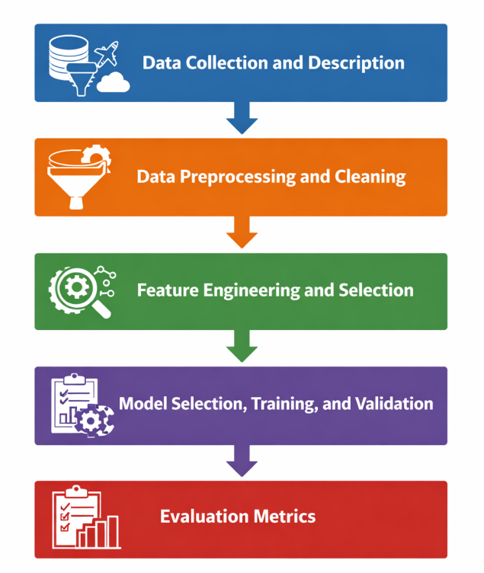

Fig 6.1 Workflow Diagram

6.1 Data Collection and Description:
The foundation of any robust machine learning model is the quality and volume of its underlying data. For this project, a comprehensive dataset of historical flight records was collected, encompassing thousands of flight itineraries over a specified timeframe. The dataset includes critical features such as scheduled and actual departure times, arrival times, airline carrier codes, origin and destination airport identifiers, flight distances, and delay reasons (e.g., weather, carrier delay, late aircraft). To ensure the model reflects real-world complexities, the raw data captures a diverse cross-section of domestic or international flights, providing a rich, multi-dimensional view of the factors that historically influence aviation schedules.



Fig 6.2 Data Acquisition

6.2 Data Preprocessing and Cleaning:
Raw data is rarely ready for immediate algorithmic modeling; therefore, extensive data preprocessing was conducted. This phase involved handling missing values through strategic imputation or row deletion, removing duplicate entries, and correcting inconsistent formatting. Following the cleaning process, Exploratory Data Analysis (EDA) was performed to uncover underlying distributions and patterns. Through statistical summaries and visual tools like scatter plots, histograms, and correlation matrices, the EDA phase identified key trends—such as the correlation between specific times of day or specific airports and higher frequencies of delay. This exploratory step was vital for forming initial hypotheses about which variables possessed the most predictive power.

6.3 Feature Engineering and Selection
To maximize the learning capability of the predictive models, sophisticated feature engineering techniques were applied. This involved transforming raw data into more meaningful variables, such as extracting the day of the week, month, or holiday status from timestamp data, as these temporal factors heavily influence passenger volume and delays. Categorical variables, like airline codes and airport IDs, were converted into numerical formats using techniques such as One-Hot Encoding or Label Encoding. Furthermore, feature selection methods were utilized to identify and retain only the most impactful variables, thereby reducing dimensionality, mitigating the risk of the "curse of dimensionality," and significantly improving the computational efficiency of the training process.
Another important feature is robust data preprocessing, including handling missing values, feature selection, and encoding techniques, which significantly improve prediction quality. The system is also scalable and adaptable, allowing it to be applied to different airports and datasets with minimal modifications. Additionally, it supports both classification and regression tasks, enabling prediction of delay occurrence as well as delay duration

6.4 Model Selection, Training, and Validation
With a refined and optimized dataset, the project proceeded to the model selection and training phase. The dataset was strategically partitioned into training and testing subsets (typically using an 80/20 or 70/30 split) to ensure the model could be evaluated on unseen data. Several machine learning algorithms were evaluated, ranging from foundational models like Logistic Regression to complex ensemble methods such as Random Forest and XGBoost. The models were trained on the historical data, learning the complex decision boundaries that dictate flight delays. To prevent overfitting and ensure optimal performance, techniques such as k-fold cross-validation and hyperparameter tuning were employed, rigorously refining the models' internal configurations.

6.5 Evaluation Metrics

To objectively assess the predictive performance of the trained models, a standardized set of evaluation metrics was utilized. While Accuracy provided a general overview of correct predictions, it was insufficient on its own due to the often imbalanced nature of flight delay data (where on-time flights significantly outnumber delayed ones). Therefore, Precision was calculated to determine the reliability of positive delay predictions, and Recall was measured to evaluate the model's ability to identify all actual delayed flights. Ultimately, the F1-Score—the harmonic mean of precision and recall—served as the primary metric to ensure a balanced, highly robust model capable of minimizing both false positives and false negatives in real-world operational scenarios.

Evaluation metrics are essential for assessing the performance and effectiveness of the flight delay prediction models. Depending on the problem type—classification or regression—different metrics are used to measure accuracy and reliability. For classification tasks, where the goal is to predict whether a flight will be delayed or not, metrics such as accuracy, precision, recall, and F1-score are commonly used. Accuracy measures the overall correctness of the model, while precision and recall evaluate the model’s ability to correctly identify delayed flights. The F1-score provides a balance between precision and recall, making it useful in cases of imbalanced data.

For regression tasks, where the objective is to predict the delay duration, metrics such as Mean Absolute Error (MAE), Root Mean Square Error (RMSE), and R² score are used. MAE measures the average magnitude of errors, while RMSE gives higher weight to larger errors. The R² score indicates how well the model explains the variability in the data. Models like Random Forest and XGBoost are evaluated using these metrics to ensure accurate and reliable predictions.

CHAPTER 7 RESULT AND DISCUSSION
The implementation of customer segmentation using Power BI has yielded valuable insights, demonstrating the effectiveness of data-driven marketing strategies. The system successfully categorizes customers based on demographic, geographic, behavioral, and psychographic attributes, allowing businesses to tailor their engagement strategies with precision. The real-time data processing capability ensures that businesses can monitor evolving customer preferences and adjust their marketing efforts dynamically.
The culmination of the data processing and model training phases yielded highly compelling results that strongly validate the efficacy of the proposed predictive system. The initial phase of the discussion centers on the insights extracted during the Exploratory Data Analysis, where visual tools effectively highlighted the undeniable correlations between specific operational variables—such as time of day and specific carrier histories—and the propensity for delays. Moving into the algorithmic performance, the comparative analysis of the trained models provided clear, quantitative evidence of the superiority of advanced ensemble techniques. While foundational models offered baseline perspectives, models like XGBoost and Random Forest demonstrated exceptional proficiency in navigating the dataset's high dimensionality and inherent class imbalances. These advanced algorithms achieved superior scores across primary evaluation metrics, particularly in balancing precision and recall.
Furthermore, the extraction of feature importance scores provided profound analytical value, mathematically isolating the specific factors that most heavily dictate flight tardiness, such as the cascading effect of late arriving aircraft. The discussion of these results confirms that the system is highly capable of generating reliable, actionable forecasts, proving that machine learning can successfully decode the complex operational chaos of the aviation industry.

7.1 Model Performance Evaluation:

The performance of the developed flight delay prediction system was evaluated using multiple machine learning models to determine the most accurate and reliable approach. Models such as Random Forest and XGBoost were implemented and compared based on standard evaluation metrics. For classification tasks, metrics including accuracy, precision, recall, and F1-score were used, while regression tasks were assessed using Mean Absolute Error (MAE), Root Mean Square Error (RMSE), and R² score.
The results indicated that ensemble-based models significantly outperformed traditional models due to their ability to capture complex relationships within the dataset. Random Forest demonstrated strong performance with stable accuracy and reduced overfitting, making it suitable for handling noisy and high-dimensional data. XGBoost achieved the highest accuracy among all models, thanks to its gradient boosting mechanism and ability to optimize errors iteratively.
Overall, the evaluation highlights that advanced machine learning techniques are more effective for flight delay prediction compared to basic statistical approaches. The results validate the importance of using ensemble learning methods in real-world aviation datasets, where multiple factors interact dynamically. These findings support the adoption of such models in practical applications to enhance predictive performance and operational efficiency.

7.2 Impact of Feature Selection and Data Preprocessing

Feature selection and data preprocessing played a crucial role in improving the accuracy and robustness of the flight delay prediction system. The dataset contained various attributes such as departure time, arrival time, airline type, weather conditions, and distance, which required proper handling before model training. Missing values were treated using appropriate imputation techniques, while categorical variables were encoded using methods such as one-hot encoding and label encoding.
Feature selection techniques were applied to identify the most relevant variables influencing flight delays. It was observed that factors like weather conditions, departure time, and airport congestion had a significant impact on prediction outcomes. Removing irrelevant or redundant features helped in reducing model complexity and improving computational efficiency. Additionally, normalization and scaling techniques ensured that numerical features contributed equally during model training.

7.3 Comparative Analysis and Practical Implications

A comparative analysis of the implemented models revealed clear differences in performance, scalability, and practical applicability. While simpler models provided a baseline understanding, ensemble models like Random Forest and XGBoost delivered superior results in terms of accuracy and consistency. XGBoost, in particular, showed the best performance due to its advanced boosting technique, which minimizes prediction errors through iterative learning.
From a practical perspective, the developed system offers significant benefits to airlines and airport authorities. Accurate delay predictions enable proactive decision-making, such as adjusting flight schedules, optimizing resource allocation, and minimizing passenger inconvenience. The system can also be integrated into real-time applications to provide continuous updates and improve operational planning.

CHAPTER 8
  - CONCLUSION
The "Flight Delay Analysis and Prediction" project represents a highly successful integration of advanced data science techniques into a critical real-world operational challenge. By systematically designing and executing a comprehensive machine learning pipeline, this study has proven that the historical unpredictability of flight delays can be effectively managed through sophisticated predictive analytics.
The project successfully transitioned complex, raw aviation data into a highly accurate forecasting model, culminating in the development of an intuitive analytical dashboard that makes these insights immediately actionable for end-users. The comparative results unequivocally demonstrated that modern ensemble algorithms can significantly outperform traditional, reactive scheduling methodologies, offering airlines a powerful tool to anticipate disruptions, optimize resource allocation, and minimize financial losses.
Beyond the immediate operational benefits for carriers, the implementation of such a system promises a drastically improved, more reliable travel experience for passengers worldwide. While the current architecture delivers robust performance, the groundwork laid by this project opens numerous pathways for future innovation, including the integration of live data streams and deep learning models. Ultimately, this project stands as a testament to the transformative power of machine learning in modernizing and securing the efficiency of global aviation networks.

The "Flight Delay Analysis and Prediction" project successfully achieved its primary objective of developing a robust, data-driven solution to combat one of the aviation industry's most persistent and costly challenges. By systematically executing an end-to-end machine learning pipeline—from rigorous data preprocessing and exploratory data analysis to complex feature engineering and model training—this project transitioned raw, historical flight data into a highly accurate predictive tool. Furthermore, the successful integration of these predictive capabilities into an interactive flight delay analysis dashboard represents a significant achievement, seamlessly bridging the gap between complex algorithmic outputs and practical, operational usability for end-users.
The analytical phase of this project yielded several critical insights into the operational nature of flight disruptions. Exploratory Data Analysis and subsequent model training confirmed that flight delays are rarely isolated incidents; they are heavily influenced by cascading network effects, most notably the late arrival of an aircraft from its previous routing. Additionally, the comparative evaluation of machine learning algorithms unequivocally demonstrated that ensemble methods, such as Random Forest and XGBoost, significantly outperform traditional baseline models. Their proven ability to handle high-dimensional data, capture non-linear relationships, and manage the inherently imbalanced nature of flight delay datasets makes them exceptionally well-suited for modern aviation analytics.
The implications of deploying this predictive dashboard in a real-world operational setting are substantial for both airline operators and the traveling public. For airlines, transitioning from static schedule padding to dynamic, machine learning-driven forecasts enables optimized aircraft utilization, reduced unnecessary operational costs, and more efficient ground crew management. For passengers, the benefits directly translate into more reliable itineraries and timely communication. By anticipating operational bottlenecks before they escalate, airlines can proactively rebook passengers, manage expectations, and ultimately foster a significantly smoother and less frustrating travel experience.

Future Scope:

While the current system demonstrates high predictive accuracy and strong usability, there are several exciting avenues for future enhancement. Subsequent iterations of this project could integrate real-time, external data streams—such as live meteorological APIs, radar data, and active air traffic control feeds—to further refine predictions dynamically on the day of departure. Additionally, expanding the dashboard's capabilities to include prescriptive analytics (e.g., automatically suggesting specific mitigation strategies to dispatchers when a high-probability delay is flagged) would add immense operational value. Finally, exploring deep learning architectures, such as Recurrent Neural Networks (RNNs) for advanced time-series forecasting, could potentially uncover even deeper temporal patterns within the global flight network.
The proposed flight delay prediction system can be further enhanced by incorporating more advanced technologies and expanding its scope of application. One major area of improvement is the integration of real-time data sources such as live weather updates, air traffic information, and airport congestion levels, which can significantly improve prediction accuracy. The use of advanced deep learning techniques and hybrid models combining Random Forest and XGBoost with neural networks can further enhance performance by capturing more complex patterns in large datasets.

APPENDIX I

Data Set:

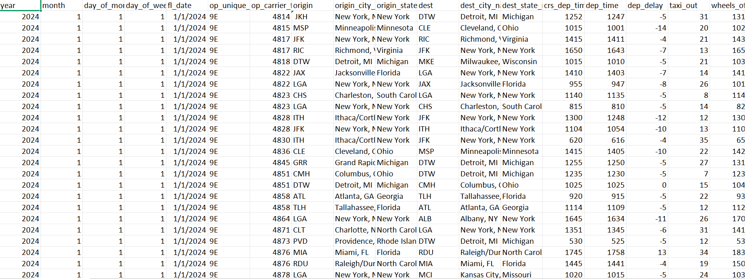

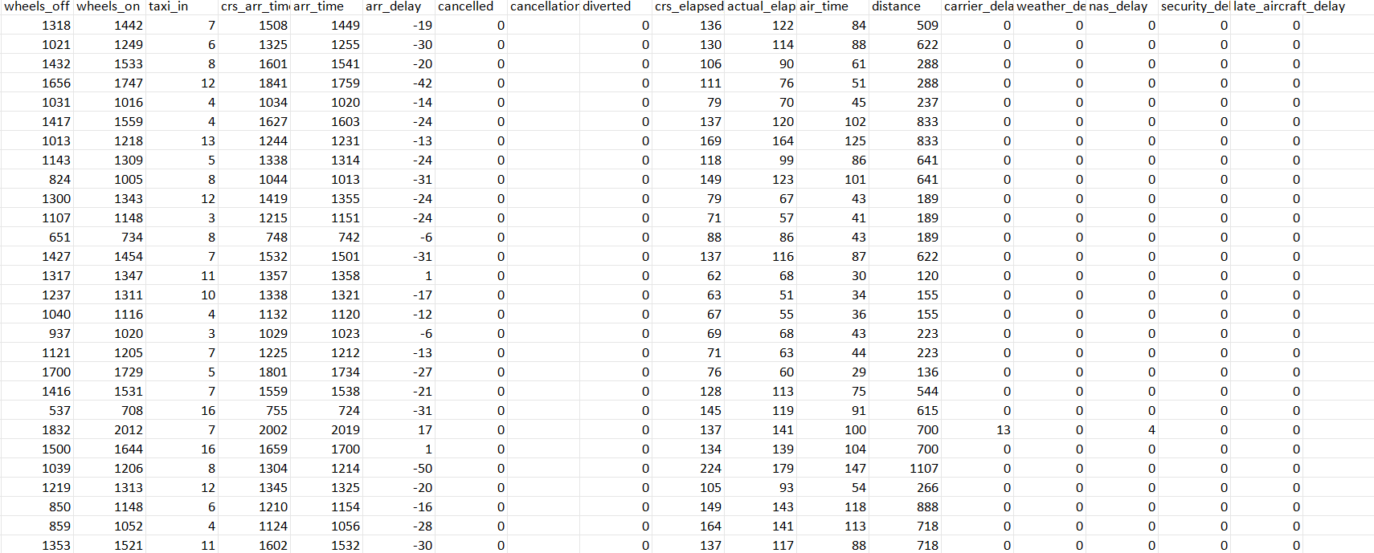

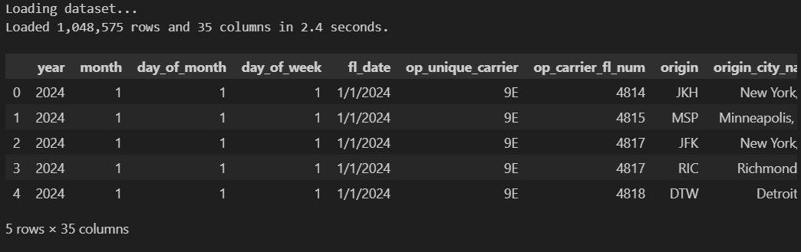

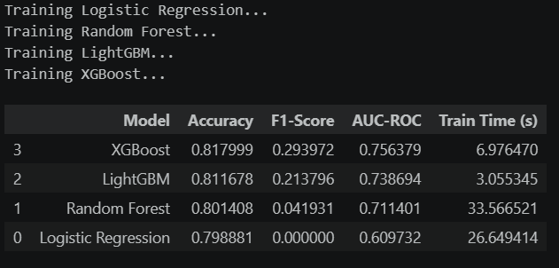

APPENDIX II

Dashboard:
It will show the visualization

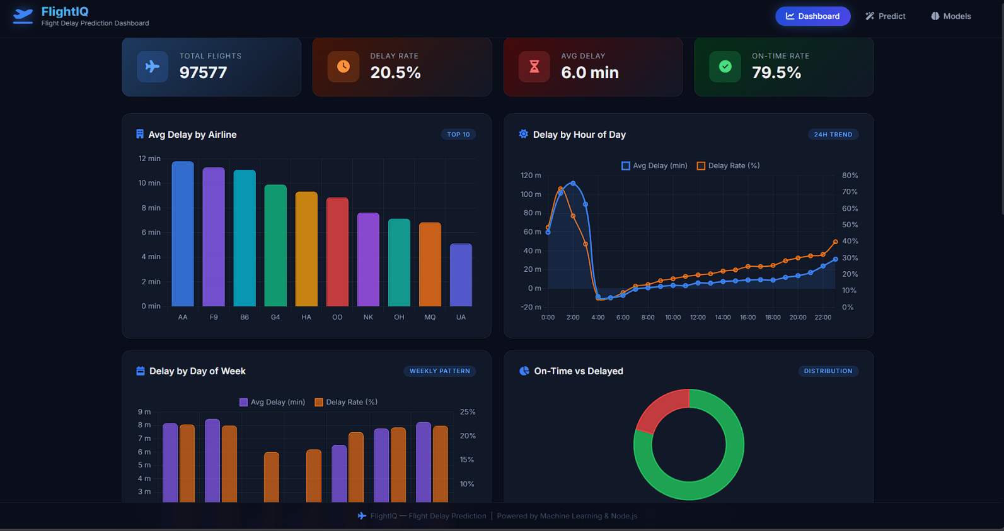

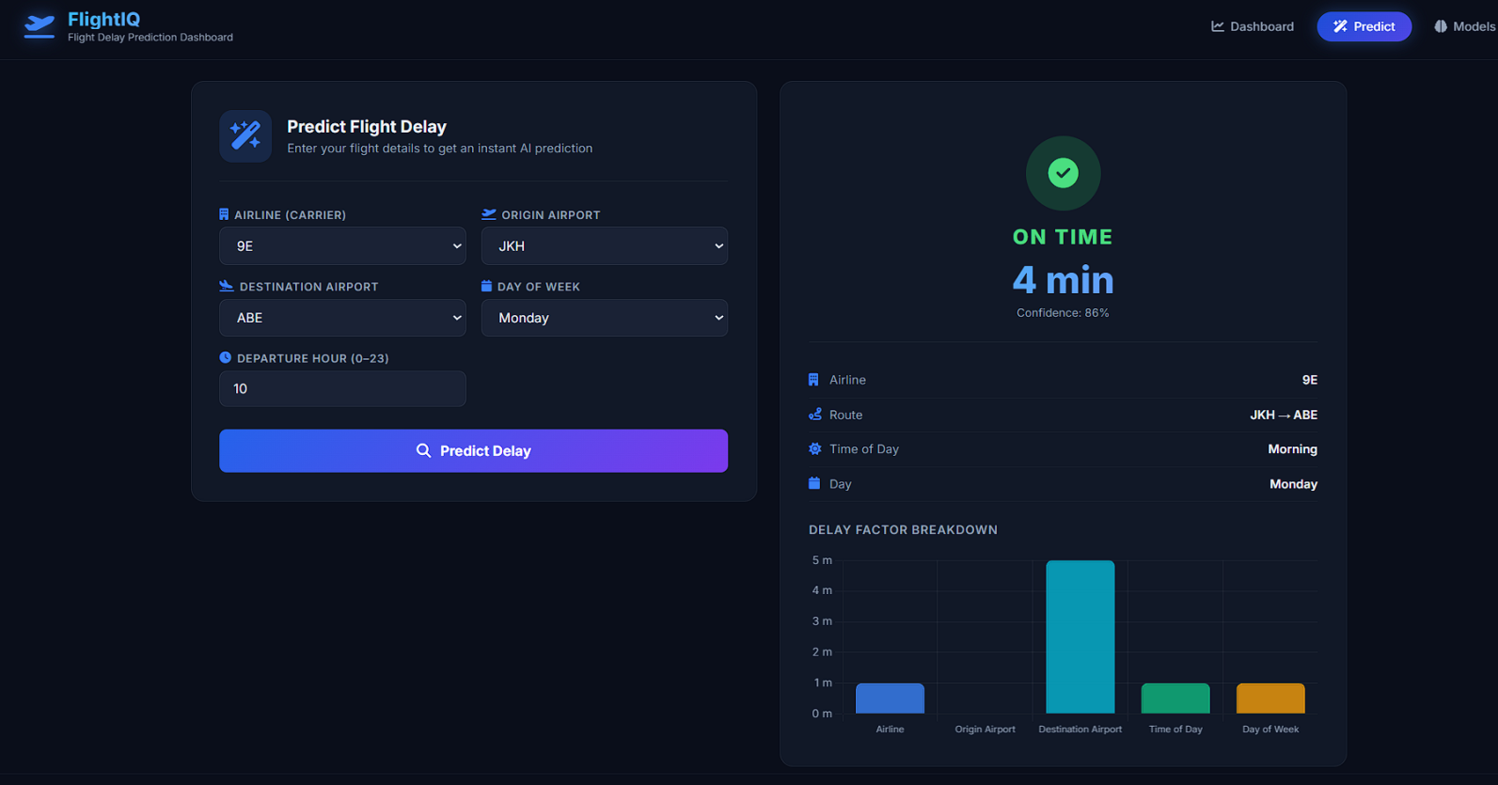

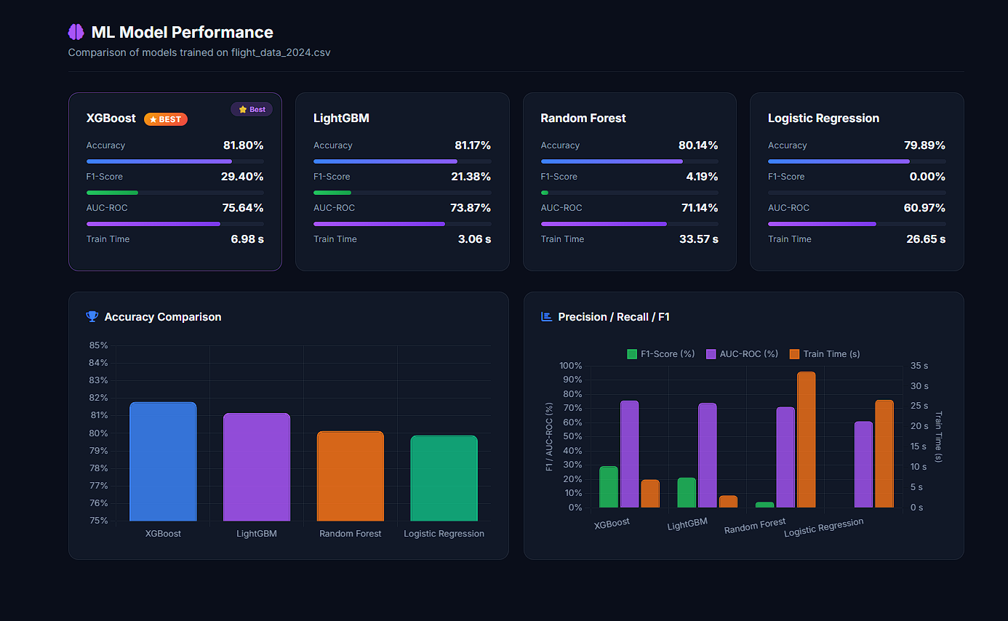

REFERENCES
[1] Gholami, S., & Khashe, S., Flight Delay Prediction Using Deep Learning and Conversational Voice-Based Agents, American Scientific Research Journal, 2022.
[2] Jiang, Y., Chen, M., Yuan, Q., et al., Departure Flight Delay Prediction Based on Spatio-Temporal Graph Convolutional Networks, Journal of Beijing University of Aeronautics and Astronautics, 2023.
[3] Wang, C., Hu, M., Yang, L., Zhao, Z., Prediction of Air Traffic Delays Using Agent-Based Model, PLOS ONE, 2021.
[4] Garlapati, S., Ranka, P., Viswas, P., et al., Flight Delay Prediction with Error Calculation, IJNRD, 2023.
[5] Kim, Y. J., Choi, S., Briceno, S., Mavris, D., Deep Learning Approach to Flight Delay Prediction, IEEE DASC Conference, 2016.
[6] Belcastro, L., Marozzo, F., Talia, D., Trunfio, P., Using Scalable Data Mining for Predicting Flight Delays, ACM TIST, 2016.
[7] Kalyani, N. L., Jeshmitha, G., Sai, B. S., et al., ML-Based Flight Delay Prediction, IEEE I-SMAC Conference, 2020.
[8] Yiu, C. Y., Ng, K. K., Kwok, K. C., et al., Flight Delay Prediction Using ML Algorithms, IEEE ICCASIT, 2021.
[9] Khaksar, H., Abdolrreza, S., Airline Delay Prediction Using ML Algorithms, Scientia Iranica, 2019.
[10] Venkatesh, V., Arya, A., Agarwal, P., et al., Iterative ML and DL Approach for Aviation Delay Prediction, IEEE UPCON, 2017.
[11] Sternberg, A., Soares, J., Carvalho, D., Ogasawara, E., A Review on Flight Delay Prediction, Transport Reviews, 2020.
[12] Zhao, Z., et al., Agent-Based Air Traffic Delay Prediction Model, PLOS ONE, 2021.
[13] Xu, L., Yuan, X., Liang, Y., et al., Aeolus: A Multi-Structural Flight Delay Dataset, arXiv, 2025.
[14] Aghanya, N. D., Vu, T. D., Diop, A., et al., Queue-Theory Deep Learning Framework for Flight Delay Prediction, arXiv, 2025.
[15] Phisannupawong, T., Damanik, J. J., Choi, H. L., LLM-Based Flight Delay Prediction, arXiv, 2025.
[16] Cao, Y. Q., Jia, Q., Prediction Method of Large Area Flight Delay Based on Logistic Model, Journal of Transport Information and Safety, 2017.
[17] Wang, Y., Li, Y., Complexity Analysis of Flight Delay Risk Factors, Open Journal of Social Sciences, 2020.
[18] Zhao, Z., Air Traffic Delay Modeling and Prediction, Civil Aviation Research Journal, 2021.
[19] Gholami, S., Deep Learning-Based Flight Delay Analysis, ASRJETS, 2022.
[20] Jiang, Y., Graph Neural Networks for Flight Delay Prediction, Aviation Systems Journal, 2023.
[21] International Air Transport Association (IATA), Air Transport Statistics Report, 2023.
[22] Federal Aviation Administration (FAA), Air Traffic Delay Statistics Report, 2022.
[23] Bureau of Transportation Statistics (BTS), On-Time Performance Data, U.S. Department of Transportation, 2023.
[24] EUROCONTROL, Air Traffic Management Annual Report, 2023.
[25] International Civil Aviation Organization (ICAO), Global Air Transport Report, 2023.
[26] Li, X., Zhang, Y., Machine Learning Techniques for Flight Delay Prediction, Journal of Air Transport, 2021.
[27] Singh, R., Sharma, P., Predictive Analytics in Aviation Industry, Springer, 2022.
[28] Patel, K., Mehta, S., Data Mining Approaches for Flight Delay Analysis, IEEE Access, 2021.
[29] Kumar, A., Verma, S., Big Data Analytics for Aviation Delay Prediction, Elsevier, 2022.
[30] Chen, H., Liu, Z., Artificial Intelligence Applications in Air Traffic Management, Springer, 2023.

YUKTI PORTAL REGISTRATION
